Submitted by-

Roll No-12

MSc 3rd semester

Date of Experiment-22/01/2021

Date of Submission-29/01/2021

**Experiment No-13**

**Topic-** PERIODOGRAM ANALYSIS

**Problem-** Given the following time series data. Carry out the Periodogram analysis for the periods 3,4,5,10,12,15 and fit the appropriate Fourier series

|  |  |
| --- | --- |
| t |  |
| 1 | 106.7 |
| 2 | 107.5 |
| 3 | 107.6 |
| 4 | 107.6 |
| 5 | 110.4 |
| 6 | 108.6 |
| 7 | 106.6 |
| 8 | 102.4 |
| 9 | 98.8 |
| 10 | 96.8 |
| 11 | 97.3 |
| 12 | 91.5 |
| 13 | 91.7 |
| 14 | 85.7 |
| 15 | 83.8 |
| 16 | 76.4 |
| 17 | 73.2 |
| 18 | 70.1 |
| 19 | 80.1 |
| 20 | 86.6 |
| 21 | 90.9 |
| 22 | 91.5 |
| 23 | 92.7 |
| 24 | 96.0 |
| 25 | 101.9 |
| 26 | 112.0 |
| 27 | 126.3 |
| 28 | 137.3 |
| 29 | 138.9 |
| 30 | 129.2 |
| 31 | 120.4 |
| 32 | 111.8 |
| 33 | 108.9 |
| 34 | 109.6 |
| 35 | 110.8 |
| 36 | 111.0 |
| 37 | 106.0 |
| 38 | 102.7 |
| 39 | 101.6 |
| 40 | 101.5 |
| 41 | 99.2 |
| 42 | 97.8 |
| 43 | 96.0 |
| 44 | 96.9 |
| 45 | 100.2 |

**Theory-**

A way of analyzing a time series from which trend and seasonal variations have been eliminated is to assume that it is made up of sine and cosine waves of different frequencies such as given below:



The objective is to estimate the periodicities  (i.e. to find which are the best value of  to select) and to evaluate the constants a1 , a2 ,…, an and b1 , b2 ,…, bn . This is known as periodogram analysis.

In periodogram analysis, we take a number of trial periods  and for each trial period , we compute the value of indicator function or intensity function. The intensity function is so chosen that when any of the trial period approaches any of the true period , it attains a local maximum. The graph of the indicator function against the trial periods is known as the periodogram. From the periodogram, the trial period against which the maximum value of the indicator function occurs is taken to be the estimate of the true periodicity.

Suppose the curve to be fitted to the observed time series is given by––



And  where k is an integer and  is the period.

Then, there will be k-complete rows of  values of yt when arranged serially and extra values are not considered in the computation. The  values can be arranged in a (k x ) array as follows:



This is known as Buys Ballot Table. If n is not a multiple of  (i.e. ) we continue writing down its rows until there are fewer  terms left. The constants A0 , A , B are obtained by minimizing the sum of squares of errors



with respect to A0 , A , B

The least square estimates of A0 , A , B are







The indicator function corresponding to the trial period  is given by––



Which is also known as the intensity function of the trial period  .  reaches a local maxima whenever  tends to  (true period). Hence, its a plot of  versus.

Finally, we fit the following Fourier series model to the given time series



**Calculation-**

For calculating , we use the following R programming

y=c(106.7,107.5,107.6,107.6,110.4,108.6,106.6,102.4,98.8,96.8,97.3,91.5,91.7,85.7,83.8,76.4,73.2,70.1,80.1,86.6,90.9,91.5,92.7,96.0,101.9,112.0,126.3,137.3,138.9,129.2,120.4,111.8,108.9,109.6,110.8,111.0,106.0,102.7,101.6,101.5,99.2,97.8,96.0,96.9,100.2)

y

a0=mean(y)

a0

m=mat.or.vec(45,1)

n=mat.or.vec(45,1)

#3#

for(i in 1:45){

m[i]=y[i]*cos((2*pi*i)/3)

n[i]=y[i]*sin((2*pi*i)/3)}

a3=(2/45)*sum(m)

a3

b3=(2/45)*sum(n)

b3

i3=(45/2)*((a3^2)+(b3^2))

i3

#4#

for(i in 1:45){

m[i]=y[i]*cos((2*pi*i)/4)

n[i]=y[i]*sin((2*pi*i)/4)}

a4=(2/45)*sum(m)

a4

b4=(2/45)*sum(n)

b4

i4=(45/2)*((a4^2)+(b4^2))

i4

#5#

for(i in 1:45){

m[i]=y[i]*cos((2*pi*i)/5)

n[i]=y[i]*sin((2*pi*i)/5)}

a5=(2/45)*sum(m)

a5

b5=(2/45)*sum(n)

b5

i5=(45/2)*((a5^2)+(b5^2))

i5

#10#

for(i in 1:45){

m[i]=y[i]*cos((2*pi*i)/10)

n[i]=y[i]*sin((2*pi*i)/10)}

a10=(2/45)*sum(m)

a10

b10=(2/45)*sum(n)

b10

i10=(45/2)*((a10^2)+(b10^2))

i10

#12#

for(i in 1:45){

m[i]=y[i]*cos((2*pi*i)/12)

n[i]=y[i]*sin((2*pi*i)/12)}

a12=(2/45)*sum(m)

a12

b12=(2/45)*sum(n)

b12

i12=(45/2)*((a12^2)+(b12^2))

i12

#15#

for(i in 1:45){

m[i]=y[i]*cos((2*pi*i)/15)

n[i]=y[i]*sin((2*pi*i)/15)}

a15=(2/45)*sum(m)

a15

b15=(2/45)*sum(n)

b15

i15=(45/2)*((a15^2)+(b15^2))

i15

mu=c(3,4,5,10,12,15)

i_mu=c(i3,i4,i5,i10,i12,i15)

i_mu

plot(mu,i_mu,type="o",

col="blue",

xlab="Trial period ----- >",

ylab="Indicator function ----- >",

main="Periodogram",

col.main="red",

lwd=2)

grid()

The value of corresponding to the trial values of the period =3,4,5,10,12,15-

|  |  |
| --- | --- |
| Trial period () |  |
| 15 | 188.490660 |
| 12 | 4925.886219 |
| 10 | 164.387800 |
| 5 | 13.784822 |
| 4 | 479.520444 |
| 3 | 2.188444 |

**Periodogram:**

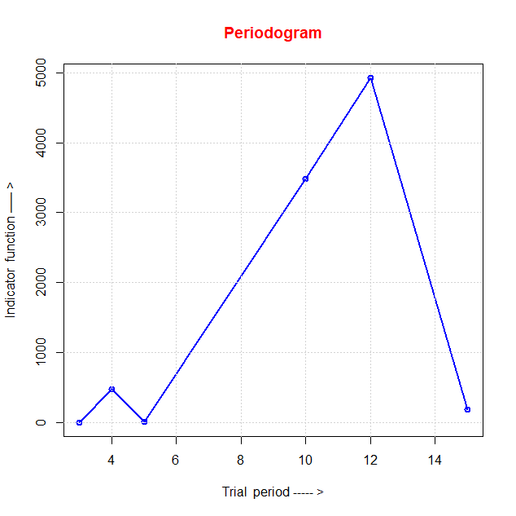

From the above calculation, we observe that the intensity function of the trial period 12 attains the maximum. Hence the trial period 12 is taken to be the estimate of the true periodicity.

Finally, we fit the following Fourier series model to the given time series:

